**ANALYZING THE DIFFERENTIAL IMPACT OF CONSUMER PRICES IN RURAL AND URBAN AREAS OF INDIA**

Research Report submitted in partial fulfilment of the requirements for the degree of Master of Business Administration.

## By

**M. Vineel Raj**

**2228618**

## Under the Guidance of

**Prof. NAGENDRA B.V.**



**School of Business and Management CHRIST (Deemed to be) University, Bangalore**

**JULY 2023**



**Declaration**

I hereby declare that the research paper entitled “**Analyzing the Differential Impact of Consumer Prices in Rural and Urban Areas of India**” has been undertaken by me for the award of Master of business administration. I have completed this study under the guidance of Prof. Nagendra B.V.

I also declare that this research Paper has not been submitted for the award of any Degree, Diploma, Associateship, Fellowship or any other title in CHRIST (Deemed to be University) or any other university.

Place: Bengaluru M. Vineel Raj

Date: (2228618)



**CERTIFICATE**

This is to certify that the project submitted by M. Vineel Raj entitled

“**Analyzing the Differential Impact of Consumer Prices in Rural and Urban Areas of India**” is a record of work done by him during my guidance and supervision in partial fulfilment of Master of Business Administration. This project has not been submitted for the award of any degree, diploma, associateship or fellowship or any other title in this University or any other University.

Place: Bengaluru

Date: Prof. Nagendra B. V Faculty, Business Analytics

School of Business and Management

CHRIST (Deemed to be University)

Bengaluru

**Acknowledgement**

I am indebted to many people who helped me accomplish this project successfully.

First, I thank the Vice Chancellor, Dr Fr Joseph C C, CHRIST (Deemed to be University) for giving me the opportunity to write my paper.

The leadership team at SBM (School of Business and Management), Bangalore Central Campus led by Dr. Jain Mathew, Dean, Dr. Mareena Mathew, Head of the Department and

Dr. Lakshmi Iyer Head of Business Analytics specialization for their kind support.

I thank Prof. Nagendra B.V, for his support and guidance during the course of

my project. I remember him with much gratitude for his patience and motivation, but for which I could not have submitted this work.

I thank my parents for their blessings and constant support, without which this project

would not have seen the light of the day.

M. Vineel Raj

(2228618)

|  |  |
| --- | --- |
| Chapter No. | **TABLE OF CONTENTS** |
|  | Abstract |
| 1 | Introduction |
| 2 | Review Of Literature |
| 3 | Project Design and Methodology |
| 4 | Data Analysis and Interpretations |
| 5 | Findings and conclusions |
| 6 | References |

## ABSTRACT

This research project aims to analyze and compare the effects of inflation on rural and urban consumers in India, utilizing the All-India Consumer Price Index (CPI) data from 2013 to 2022. The Consumer Price Index serves as a crucial economic indicator, providing insights into changes in the cost of living and purchasing power of households. By studying the CPI trends in rural and urban areas, this research seeks to shed light on the disparities in inflation rates and their implications on different segments of the population.

**Chapter 1** introduces the background and rationale for the study, emphasizing the significance of understanding inflation's impact on diverse consumer groups. The purpose of the research is to explore trends, patterns, and relationships within the CPI data.

**Chapter 2** presents a comprehensive literature review, analyzing 'for and against' arguments related to the topic. This section critically assesses existing concepts and models, highlighting areas where further investigation is needed to justify the research's scope and relevance.

**Chapter 3** outlines the research methodology, stating the problem and defining the study's objectives. Data sources, including primary and secondary data, are discussed, providing a basis for the research work conducted in the following chapters. Limitations of the study are also acknowledged to ensure the validity of the findings.

**Chapter 4** delves into the industry overview, offering historical insights into the CPI sector's evolution and its current status. This chapter explores the global and Indian scenario of CPI, highlighting major players in the sector who collect and analyze CPI data to inform economic policies.

**Chapter 5** presents the analysis and findings obtained from studying the CPI data. Time series analysis, regression, and trend identification techniques are employed to understand inflation dynamics in rural and urban areas. Key observations are derived, shedding light on differential impacts on consumers in different regions and sectors.

**Chapter 6** concludes the research, summarizing the key findings and implications for policymakers, businesses, and consumers. Recommendations are provided to address inflationary challenges and promote sustainable economic growth, taking into account the welfare of vulnerable sections of society.

In conclusion, this research project aims to contribute valuable insights into the differential impact of inflation on rural and urban consumers in India. By utilizing the CPI data and analytical methods, this study provides a deeper understanding of inflation trends, guiding policymakers towards effective and inclusive economic measures.



**Consumer Price Index** or **CPI** is the measurement of the overall change in the consumer prices based on the representative basket of goods and services for a particular period of time. This usually calculated monthly or quarterly or even half yearly for various economic decision-making purposes. This CPI is one of the major factors taken into consideration to evaluate the inflation rate of a country. This is a very important macroeconomic factor for the policy makers in the government to frame economic policies based on the increase and decrease in the prices of various commodities according to their usages and the demand. This also play a major role in decision making for the central banks of the nation in increasing or decreasing the interest rates. This in turn impacts the business environment and changes the whole course of economy.

With the data on the CPI, the government can implement

1. Tax rates for products
2. Import/Export duties
3. Regulate demand and supply in the market
4. Recommend employee compensation rates for the laborer.
5. Determine Repo rates

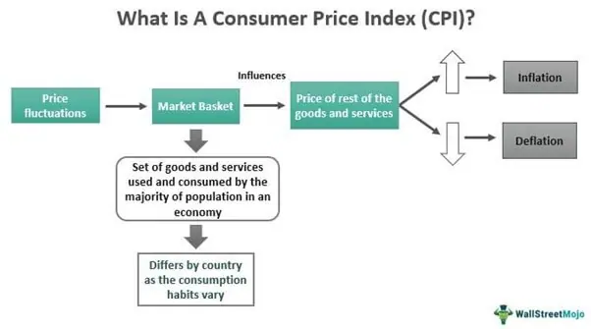1.1 Background of the Study:

The research aims to investigate the differential impact of inflation on rural and urban consumers in India using the All-India Consumer Price Index (CPI) data up to December 2022. Inflation is a crucial economic indicator that reflects changes in the general price level of goods and services over time. Understanding how inflation affects consumers in rural and urban areas can provide valuable insights into their economic well-being and help policymakers formulate targeted measures to address potential disparities.

1.2 Need and Rationale of the Study:

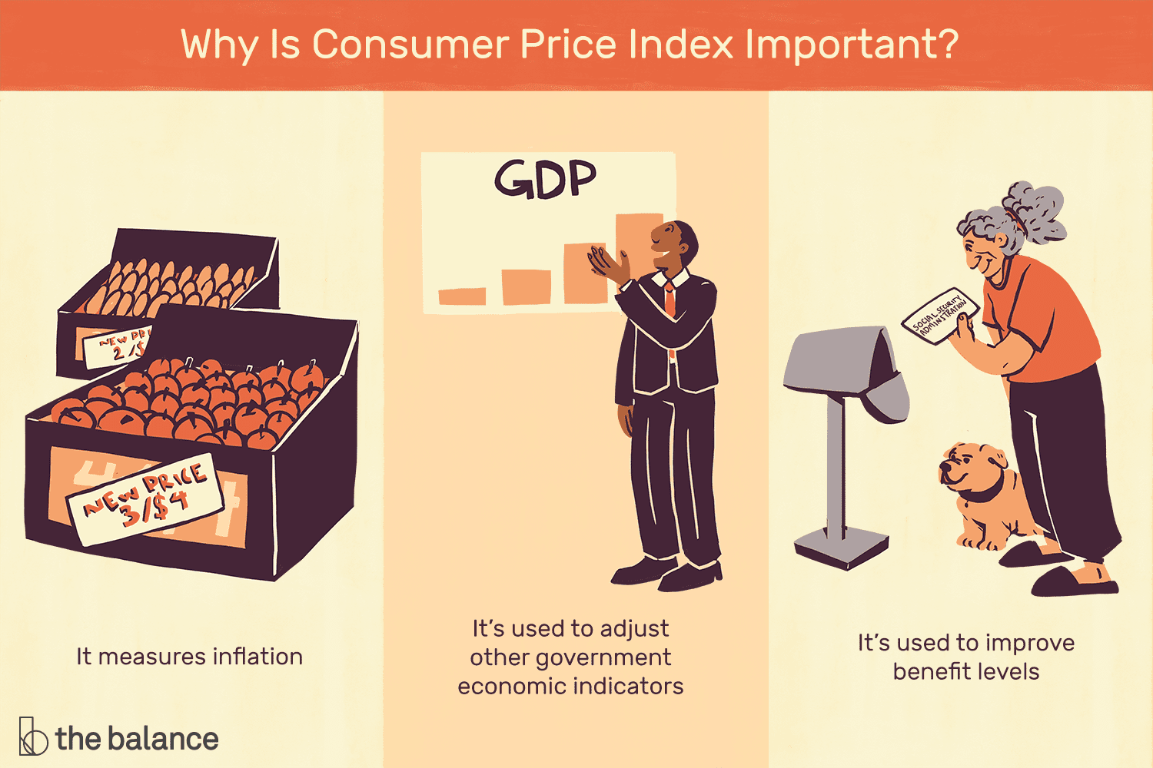The need for this study arises from the significant differences in the living standards and consumption patterns between rural and urban populations in India. Inflation can have varying effects on different consumer groups based on factors such as income levels, expenditure patterns, and access to goods and services. By analyzing the impact of inflation separately for rural and urban consumers, this research seeks to uncover any disparities and implications for economic policy.

The study's rationale lies in its potential to contribute to a more comprehensive understanding of inflation's nuanced effects on rural and urban communities. By identifying specific commodities or sectors that experience significant price fluctuations in each area, policymakers can design region-specific strategies to mitigate inflationary pressures and ensure equitable economic development.

1.3 Purpose of the Study:

The main purpose of this study is threefold:

* To analyze and compare the effects of inflation on consumer prices in rural and urban areas of India using the All-India Consumer Price Index (CPI) data.
* To conduct time series analysis on the CPI data to identify trends, seasonality, and cyclic patterns in the inflation rates over time for rural and urban areas.
* To examine the impact of various factors, such as food prices, fuel prices, and other economic indicators, on inflation in rural and urban regions through regression analysis.

By achieving these objectives, the study aims to provide valuable insights for policymakers and researchers to make informed decisions and address potential disparities in inflation's impact on rural and urban consumers in India.



## LITERATURE REVIEW

## CONSUMER PRICE INDEX (CPI) AS A COMPETITIVENESS INFLATION MEASURE

## As foreign trade competitiveness is an essential part of global competitiveness, and in order to achieve the objectives of this paper, we are going to adopt the consumer price index (CPI) as a competitiveness measure. The Consumer Price Index (CPI) is a measure that examines the weighted average of prices of a basket of consumer goods and services, such as transportation, food and medical care. It is calculated by taking price changes for each item in the predetermined basket of goods and averaging them. Changes in the CPI are used to assess price changes associated with the cost of living, the CPI is one of the most frequently used statistics for identifying periods of inflation or deflation.

## The existence of linkages between the level of the real exchange rate and the rate of inflation has been more commonly established in the theoretical literature. In order to achieve the purpose of this paper we’ve collected the primary data needed from the Jordanian Department of Statistics (DoS), then we calculated the CPI’s rates for the period 2010– 2018. The average exchange rate of the Jordanian dinar against the Euro was also collected from the records of the Central Bank of Jordan. The reason behind choosing the exchange rate of Euro and not USD currency is because, the USD is fixed against the Jordanian Dinar JD, in other words, the government of Jordan has assigned a fix stable exchange price of JD against the USD which equal to 0.71. Table 1 illustrates the average exchange rates of the JD against the Euro for the period 2010-2018.

## A RESEARCH PAPER ON A STUDY ON PRICE INDICES METHODS IN INDIA

## Different Price Index methods have been found failure in reflecting real inflation condition in economy in India at present. Out of three types of price indices being brought under use for measuring the inflation viz. Whole Sale Price Index (WPI), Consumer’s Price Index (CPI) and Producer’s Price Index (PPI), none of them is found full proof. Each type of price index is suffering from its own limitations. CPI in India is used as the popular and handy statistical tool of measure of retail inflation by govt. and all other concerned. But it is too weak price index to become a reliable tool. It is observed that there is no consistency between CPI and actual retail inflation. PPI which takes only the price change of inputs of the production, can be used by industrial countries like USA only. It is good for nothing in Indian economic environment. Basic loophole of present CPI is that it gives the weightage to the commodities included in CPI construction only category wise. Weightage according to the income level group of the consumer is not taken into account. This is the basic cause of inconsistency between CPI and actual inflation.

## The Consumer Price Index

## Triplett’s 1975 survey reviews a small number of studies that attempt to assess the quality of the CPI service price indexes. Four of the six studies he reviews examine the medical services component of the CPI, and three of these four find upward bias in the CPI components. However, the main conclusion that Triplett draws from these studies is that the appropriate pricing concept in the medical services area is not very well defined.

## The Consumer Price Index as a Measure of Consumer Price Inflation

## Upon reviewing the literature and analyzing the results from the data gathered, it can be determined that the Consumer Price Index is in fact an accurate measure of consumer price inflation. The CPI however, not only depicts a measurement of a percentage change in consumer price inflation but also to an extent reveals as to what impacts it would have as shown in the study. Therefore, an increase in consumer price inflation rates would cause a percentage increase in the CPI as well which thereby fundamentally reduces the consumer spending power as the prices of the items within the basket of goods rise. The CPI can hence be used as a means to depict the impacts on consumer price inflation on the consumer spending power and to an extent the impacts it has on the economy; it is important to remember that it is not enough to only consider the values of the index in order to determine what impacts of inflation that pertain to the economy as other influencers will have to be considered in order to draw a complete picture. However, in regards to using the CPI as a means of measure, the study as shown that it can draw an accurate picture and provide a clear-cut comparison providing the data and values used are true.

## The Consumer Price Index: A Research Agenda and Three Proposals

## Professional conventions are a bureaucratic necessity precisely because they limit the scope for individual discretion, and thus imply decisions that are less personal and less dependent on the whims and prejudices (as well as the professional judgments) of the individuals who happen to be responsible for making them. Thus, such conventions can be viewed as a strategy for limiting the role of subjective factors in decision making. In the case of the CPI, economists and others often appeal to the theory of the cost-of-living index for a principled resolution of technical issues. Yet economists know that the theory of the cost-of-living index, like any theory, rests on assumptions that are often unrealistic. The technical problems of the CPI intersect the political problems of taxation, intergenerational efficiency, and intergenerational equity because the CPI is used to index tax brackets and various payments, including Social Security and the pensions of retired federal workers. Even in a world with a single, homogeneous consumption good and thus a world with no index number problems to complicate measuring the rate of inflation, society would face the threshold public policy question of whether to maintain the real value of the benefits of retired workers (by linking benefits to the consumption good) or to allow the real value of benefits to vary (for example, by linking benefits to the wages of active workers.

**CHAPTER 3**

**PROJECT DESIGN AND METHODOLOGY**

## 3.1 Statement of Problem

## The main problem addressed in this research is to analyze the differential impact of inflation non rural and urban consumers in India. The study aims to understand how inflation affects consumer prices in these two demographic segments and identify any disparities in their purchasing power and overall economic well-being.

## 3.2 Objectives of the Study

## The research is guided by the following objectives:

## To compare the inflation rates and consumer price indices (CPI) between rural and urban areas of India.

## To identify the factors that contribute to the differential impact of inflation on rural and urban consumers.

## To conduct a time series analysis to identify trends, seasonality, and cyclic patterns in the inflation rates for both sectors.

## To examine the relationship between CPI values and other variables, such as food prices and fuel prices, to understand their impact on inflation in rural and urban areas.

## 3.3 Sources of Data

## To achieve the research objectives, the study will utilize the State Level Consumer Price Index (CPI) data available from the official data portal of the Government of India (<https://data.gov.in/catalog/state-level-consumer-price-index-ruralurban>).

## The study will primarily rely on secondary data from the State Level CPI dataset, which contains information on rural and urban CPI values across various commodities and sectors.

## Secondary Data

## The secondary data will be extracted from the State Level CPI dataset, which includes monthly CPI values for different commodity categories, such as Cereals and products, Meat and fish, Milk and products, Fuel and light, etc., for rural and urban areas from the year 2013 to the 2022.

## 3.4 Description of the Research Work

## The research work will involve the following steps:

## Data Collection: The State Level CPI data will be obtained from the official data portal of the Government of India. The data will be carefully curated and cleaned to ensure accuracy and consistency.

## Data Analysis: Data analysis will involve comparing the CPI values and inflation rates between rural and urban areas for different commodity categories. Time series analysis will be conducted to identify trends, seasonality, and cyclic patterns in the inflation rates.

## Regression Analysis: Regression analysis will be performed to examine the relationship between CPI values and other variables, such as food prices and fuel prices, for both rural and urban sectors.

## Analysis of General Index: The research starts by examining the general index of all commodities from 2013 to 2022. The findings indicate a significant increase in the consumer price index over the past decade

## Increase in Essential Goods and Services: The study also focuses on essential goods and services, such as food, housing, health, and education.

## Contribution of Non-Essential Activities: The research analyzes the contributions of non-essential activities to the increase in the general index. The R-squared values for these activities are high, indicating a good fit for the increase in the price index.

## Limitations of the Study

## The research may encounter certain limitations, including:

## Data Completeness: The availability of complete data for all commodity categories and sectors may vary, affecting the comprehensiveness of the analysis.

## Data Quality: The accuracy and reliability of the State Level CPI data may be subject to occasional discrepancies or reporting errors.

## Data Interpretation: The analysis of the CPI data is based on historical trends and may not account for unforeseen events or economic shocks.

## Generalization: The findings may be limited to the time period and geographical scope covered by the State Level CPI data.

**CHAPTER 4**

**INDUSTRY OVERVIEW**

## 4.1 History of the Consumer Price Index (CPI) Industry

## The concept of the Consumer Price Index (CPI) dates back to the early 20th century when economists and policymakers sought to measure changes in the cost of living for households. The first official CPI was introduced in the United States in 1919, and over time, it became an essential tool for tracking inflation and making informed economic decisions. The CPI methodology evolved, and many countries, including India, adopted and adapted the index to suit their economic contexts.

## 4.2 Growth and Current Status of the CPI Industry

## The CPI industry has witnessed significant growth and evolution over the years. With advancements in data collection methods, statistical techniques, and computing power, the accuracy and relevance of CPI measurements have improved. Governments and central banks around the world rely on CPI data to formulate monetary policies, adjust interest rates, and understand the overall economic health. In India, the Ministry of Statistics and Programme Implementation (MoSPI) publishes the CPI data for rural and urban areas regularly, providing vital insights into inflation trends for policymakers and consumers.

## 4.3 Global and Indian Scenario of CPI

## The CPI is a widely adopted economic indicator globally. Various countries, regions, and international organizations, such as the United Nations and the International Monetary Fund (IMF), use CPI data to monitor inflation, assess economic stability, and make informed policy decisions. In India, the CPI serves as a crucial tool to gauge price movements and assess the purchasing power of consumers. It plays a pivotal role in determining the effectiveness of government policies and interventions in managing inflation and ensuring equitable economic growth.

## 4.4 Major Players in the CPI Sector

## The CPI sector involves multiple stakeholders, including government agencies, statistical departments, research institutions, and economists. Major players in this sector include the Ministry of Statistics and Programme Implementation (MoSPI) in India, the United States Bureau of Labor Statistics (BLS), Eurostat in the European Union, and similar organizations in other countries. These entities are responsible for collecting, analyzing, and disseminating CPI data to the public and policymakers.

## Chapter 5

## ANALYSIS AND FINDINGS

## 1. Time Series of General Index

## 

## The General Index is evidently been rising over the years, it means that that with each passing year the purchasing power of consumers has been reducing, this is less in rural

## areas as the general index are higher than the urban areas.

## 2. Inflation Trend

## There is evidently an increase in the inflation levels of both the rural and urban demographics, an increase in inflation is often associated with a higher cost of living. Basic necessities such as food, housing, and healthcare become more expensive, impacting households' budgets and potentially reducing disposable income.

## 3. Dashboard of Consumer Price Index

**Interpretation:**

* From the above charts, we can find that the consumer price index has increased in past decade in a significant level.
* The first chart shows the increase in the general index of all commodities from the period 2013 to 2022.
* The General index in the year 2013 was 110 and in the year 2022 it has increased to 171.
* Over the course of 10 years, the general index has increased by 55.45% with an average increase of 5.5% every year which also depicts the inflation rate.
* From this we can conclude that the healthy inflation rate for a nation is 5% and it is being sustained in this case.
* In the second chart we have compiled the increase in the consumer price index of essential goods and services like food, housing, health and education.
* Among the 4 above mentioned categories, we find that housing has had the highest increase from 40 in the year 2013 to 107 in 2022 with an increase of 260% and an average of 26% every year.
* Also, the price index of health has increased from 107 to 174 which is a 7% increase every year and the demand has been rising each year.
* From the above charts, we can find that the consumer price index has increased in past decade in a significant level.
* The first chart shows the increase in the general index of all commodities from the period 2013 to 2022.
* The General index in the year 2013 was 110 and in the year 2022 it has increased to 171.
* Over the course of 10 years, the general index has increased by 55.45% with an average increase of 5.5% every year which also depicts the inflation rate.
* From this we can conclude that the healthy inflation rate for a nation is 5% and it is being sustained in this case.
* In the second chart we have compiled the increase in the consumer price index of essential goods and services like food, housing, health and education.
* Among the 4 above mentioned categories, we find that housing has had the highest increase from 40 in the year 2013 to 107 in 2022 with an increase of 260% and an average of 26% every year.
* Also, the price index of health has increased from 107 to 174 which is a 7% increase every year and the demand has been rising each year.

## 4. Dashboard of Non-Essential Activities

## 

## Interpretation:

## The above charts mention the contributions of non-essential activities to the increase in the general index in the past decade.

## We can find that the respective Rsquare values of these services are 0.9584, 0.9779, and 0.9745.

## This shows that all these activities are ceding good fit for the increase in the price index.

## We can conclude that the contribution for the increase in the price index rise can be from the non-essential services industries also.

## 5. Dashboard of Health and Fuel and Light

## 

## Interpretation:

## In the above charts, we analyze the impact on health and impact on transport by the factors affecting it.

## We notice that the Rsquare value is 0.9596 which indicates that as the price index of fuel and light increases, the index of clothing and footwear also increases.

## In the first chart, we find that the relation between the index of Pan, tobacco& intoxicants and health is high with the value of 0.9377.

## Increase in the usage of unhealthy products has led to the demand in health services thus increasing its prices.

## In the second chart, we have found that there is strong relation between fuel & light and transportation.

## We can also see that the price of fuel increases as the demand or the usage increases.

## As the cost of fuel increases, the cost of transportation also increases as it is seen from the Rsquare value of 0.9263.

## 6. Comparison of prices of various product categories

## 

## From the above chart the prices of the basic household necessities have seen an increase, the price of meat products has drastically increased post covid, also the price of fuel and light has also seen an increase in the price which can be attributed to the regulations imposed by OPEC owing to the Petro Dollar agreement.

## 7. Comparison of Fuel price and Transport cost.

## This chart helps us understand the relation between fuel price and transport cost, as the price of fuel increases the cost of transportation also increases, this can erode the savings of households over time. Rural areas may face challenges in accessing essential services, such as healthcare, education, and markets. Rising transportation costs can further limit access to these services, especially if public transportation options are scarce.

**CHAPTER 6**

**RECOMMENDATIONS**

## Policymakers can focus on measures to increase the supply of goods and services in the economy. This can include investments in infrastructure, reducing bureaucratic barriers to production, and supporting businesses to expand their capacities

## Encouraging competition in markets can help keep prices in check. Policymakers can implement antitrust measures to prevent monopolistic practices that may lead to price manipulation.

## Encouraging wage and price moderation can help prevent a spiral of increasing costs and wages that feed into higher inflation. This can be achieved through wage negotiations, cooperation between labor and management, and social dialogue.

## Encourage the use and development of alternative and renewable energy sources to reduce reliance on fossil fuels and provide greater energy security.

## Create a price stabilization fund that can be used to buffer consumers from sudden and significant price increases. This fund can be financed through contributions from the government.

## Consider entering into long-term fuel supply contracts with producing nations to secure stable prices and reduce exposure to short-term price volatility.

## The spending on health can cause the people prevent taking services like education and other necessities, to prevent this situation, the taxes on unhealthy commodities can be increased and prevent the people from usage.

## The tax rates on the non-essential goods and services including unhealthy commodities can be increased on the next tax circle.

## REFERENCES

1. *What Is the Consumer Price Index?* (n.d.). The Balance. https://www.thebalancemoney.com/consumer-price-index-cpi-index-definition-and-calculation-3305735
2. Shaban, O. S., Al-Attar, M., Al-Hawatmah, Z., & Ali, N. N. (2019). Consumer Price Index (CPI) as a competitiveness inflation measure: Evidence from Jordan. *Journal of Governance and Regulation*, *8*(2), 17–22. https://doi.org/10.22495/jgr_v8_i2_p2
3. Ghosh, T., Sahu, S., & Chattopadhyay, S. (2020, May 24). Inflation expectations of households in India: Role of oil prices, economic policy uncertainty, and spillover of global financial uncertainty. *Bulletin of Economic Research*, *73*(2), 230–251. https://doi.org/10.1111/boer.12244

## Bryan, Michael & Cecchetti, Stephen. (1993). "The Consumer Price Index As a Measure of Inflation". Economic Review. 29. 15-24.

## Wynne, Mark & Sigalla, Fiona. (1994). The consumer price index. Economic and Financial Policy Review. 1-22.

1. Pollak, R. A. (1998). The Consumer Price Index: A research agenda and three proposals. *Journal of Economic Perspectives*, *12*(1), 69–78. https://doi.org/10.1257/jep.12.1.69